**Assignment-3**

**Table of department**

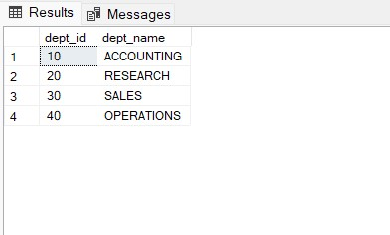

**Table of employee**

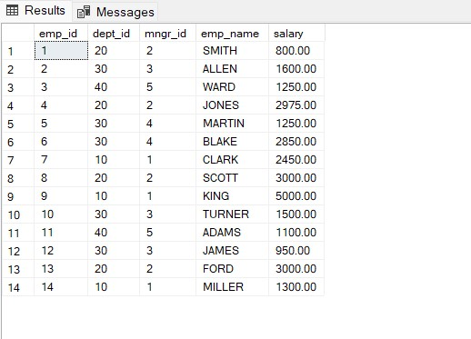

**1.write a SQL query to find Employees who have the biggest salary in their Department**

select emp_name, maxsalemp.biggest_salary from Employee E

inner join

(select dept_id,MAX(salary) as biggest_salary

from Employee

Group by dept_id) maxsalemp

on E.dept_id = maxsalemp.dept_id

where E.salary = maxsalemp.biggest_salary;

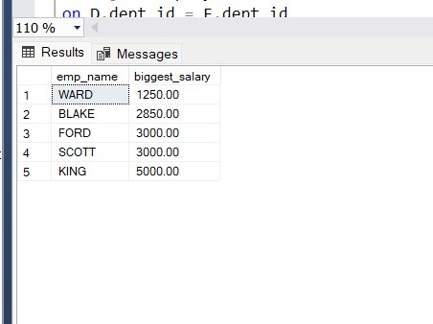

**2. write a SQL query to find Departments that have less than 3 people in it**

select dept_name,count(emp_id)

from Department D

left join Employee E

on D.dept_id = E.dept_id

group by D.dept_name

having count(emp_id)<3

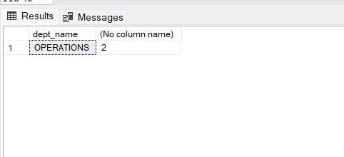

**3. write a SQL query to find All Department along with the number of people there**

select dept_name,count(emp_id)

from Department D

inner join Employee E

on D.dept_id = E.dept_id

group by D.dept_name

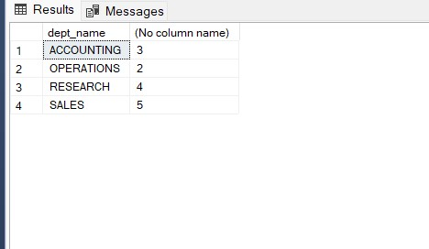

**4. write a SQL query to find All Department along with the total salary there**

select D.dept_name,sum(E.salary)

from Department D

inner join Employee E

on D.dept_id = E.dept_id

group by dept_name

